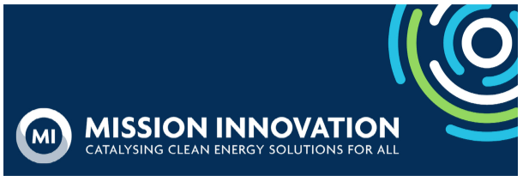
Member Bulletin - 23 June 2023

Dear MI Members and Collaborating Organizations,

We hope these updates find you well as June nears its end. Please read on for the latest MI-8 and other MI updates.

MI-8
- We are pleased to share the Logistics Note prepared by our hosts (attached). This includes important information on:
  - Venues
  - Accommodation booking
  - Provisional programme
  - Travel requirements
- Side event organisers have now been notified of the date, time and venue of their side events by our hosts. A full side event calendar is viewable on the ministerial website.
- Our hosts are working on the concept notes for the Roundtables and have invited private sector participants. Roundtable topics and times are included in the Logistics Note.
- A CEM/MI briefing was held on 23 June. The slides, recording and a summary of key points will be circulated in week commencing 26 June.
- We will also schedule an MI member briefing in early July, focused on MI-specific content.
- The MI-8 Pre-Read will be sent to all MI points of contact on 30 June, and will include all available information at that time. A second version of the pre-read may be sent closer to the Ministerial, depending on when information becomes available from the host.
- If you have not already done so, members should email info@cem-mi-india.org and CC secretariat@mission-innovation.net the contact details of a nominated member of their delegation who could act as their Delegation Coordinator (firstname; lastname; email). A personal link will be sent to the Delegation Coordinator, allowing them to log in to the online portal, where they will be able to add the details of the full delegation. The portal will include the option to request a personalised visa letter for each delegate. The registration deadline is 30 June.
- Public registration is now open on the ministerial website. Please share this information with your clean energy community.

Missions
- Second-wave Missions held workshops, advancing discussions around the value proposition of private sector engagement with their Missions.
- This month, the Urban Transition Mission (UTM) chaired a multi-level dialogue at the Daring Cities conference and a high-level panel in collaboration with the UNFCCC global innovation hub. UTM cities, Turku, Chefchaouen, and Puerto Montt participated in these events. Additionally, at a workshop hosted by the UNFCCC global innovation hub in partnership with UTM, 11 UTM pilot cities showcased their efforts in sustainable urban development and discussed the role of innovation in addressing human needs and achieving resilient, net-zero communities with representatives from national governments, businesses, academia, and venture capital.
- The Integrated Biorefineries Mission held its first webinar, where member countries discussed the priorities of the Mission with industries, researchers, and policymakers. Watch the webinar here.

Innovation Platform - Collaborate
- The Global Cooling Pledge was conceptualised at COP27 with the UAE COP28 Presidency. The aim is for signatory nations to commit to mitigating the emissions from cooling and providing sustainable access. The Pledge includes a number of commitments and initiatives, including signing the Kigali Amendment to the Montreal Protocol and raising Minimum Energy Performance Standards (MEPS) for air conditioning equipment. The MI Innovation Community (IC) has been instrumental in ensuring the commitment to innovation in cooling.
- The Pledge will likely be presented at the MI-8/ G20 Meeting in Goa in July and launched at COP28 in November. The IC plans to host a side event at COP with the UAE and contribute to other events/ demonstrations in cooling innovation.
- The IC on Affordable Heating and Cooling of Buildings is planning to host a side event themed “Transition towards Low-carbon Affordable Heating and Cooling Solutions -The way ahead” to discuss priority areas such as Efficient Refrigeration Systems, Alternate Heating & Cooling Technologies, Effective Demand Response, and Smart Operations.

If you have any updates that you’d like to share for consideration in the next Member Bulletin, please direct them to the MI Secretariat inbox, secretariat@mission-innovation.net.

