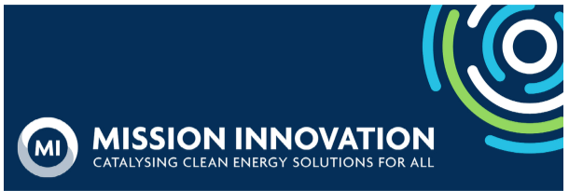
Member Bulletin - 13 October 2023

Dear MI Members and Collaborating Organizations,

Thank you to those who have submitted their responses to the MI Member Survey 2023; we kindly request your responses by 30th October. Additionally, our COP28 planning is moving along! Please let us know of your event plans and attendance, or of you would be interested in representing MI in a speaker role. Read on to find additional updates below!

COP28
- MI successfully held the first COP28 Taskforce meeting this week, with representatives from Breakthrough Energy, KAPSARC, IEA, IRENA, European Commission and JRC, US, UK, Australia, Chile, Global Covenant of Mayors, the Urban Transition Mission, and the Green Powered Future Mission. It is clear MI provides a unique platform for collaboration, and there are so many ways our members can support MI’s objective as well as supporting each other. The next meeting, scheduled for 8 November from 15:30 – 16:30 CEST, will focus on developing a narrative for innovation at COP, which will inform the comms toolkit that will be shared with all members.
- We kindly remind you to inform us of innovation events planned, even tentatively, for COP28 (event title, location, and time if possible).
- Please also let us know of attendance, so we can respond to requests for speakers to represent MI from our event partners. If interested in seeing a list of speaking opportunities from our event partners, please email the Secretariat at secretariat@mission-innovation.net.

Missions
- We are very excited to share a highlight of the Waterborne Days Conference, organized by the European Commission on 26/27 September, where our very own Deputy Mission Director Mette Jensen participated to the roundtable “What role can Europe’s R&I play in global efforts towards emissions reduction?”. Mette’s keynote address touched upon the challenges for the decarbonization of shipping in the international dimension. The discussion focused on specific topics, including the strategic deployment of fuels and the vital importance of maintaining a level playing field across the entire value chain. The success of the event is a testament to our collective dedication to shaping the future of sustainable shipping!

Innovation Platform -Collaborate
- Save the date for the 5th Public Funders Dialogue Meeting, to which public funding networks and relevant stakeholders are invited on 21 November from 13:00 – 15:00 (CET) for thematic scoping of priorities for the MICall24. The meeting will focus on facilitating and accelerating collaboration on thematic synergies and joint calls for 2024 and beyond, between Mission Innovation, Clean Energy Transition and Driving Urban Transition Partnerships. If you have any questions, please contact: gerlinde.mueckstein@ait.ac.at

Innovation Platform - Insights
- Please remember to submit your responses to the MI Member Survey 2023 to secretariat@mission-innovation.net by 30 October. This survey collects information on clean energy R&D activities that took place over the last year and will be published in our annual report. This year we are excited to launch the report at COP28, maximising the opportunity to showcase the achievements of our members over the past 12 months thereby galvanising the leadership role of MI members in the clean energy landscape.

Other
- One of our longest serving and active member representatives, Dr. Sangita Kasture, has a new role and will no longer be participating in MI. Sangita has contributed to MI for the past seven years, in the first phase of MI as a co-lead of the Analysis and Joint Research Sub-Group, overseeing the Innovation Challenges (ICs), including hosting, and organising a memorable IC meeting in Delhi in November 2019. She was also central to the organisation of the 2022 Annual Gathering in India and to the development of the Integrated Biorefinery Mission. We invite you to add your well wishes and photographs to her Kudoboard by Friday 20 October.
If you have any updates that you’d like to share for consideration in the next Member Bulletin, please direct them to the MI Secretariat inbox, secretariat@mission-innovation.net.

Sincerely,
MI Secretariat



