2nd Steering Committee meeting
Notes - 1st June 2023

Attendees | - EC – Philippe Froissard, Laura Hetel  - GCoM – Andy Deacon  - JPI UE – Margit Noll  - Austria – Hans Günther Schwarz  - Spain – Ignatio Garcia Fenoll (alternate), Julio Lumbreras (new representative,) Eva Gonzales (SGCI, support)  - Sweden – Emina Pasic  - World Economic Forum – Cristina Gomez  - EnoLL – Martina Desole  - IC7 – Graeme Maidment, Piero De Bonis  - UNFCCC – Carlos Ruiz-Garvia
Agenda – Discussion points | - Welcome and setting the scene  - UTM Action Plan 2023: Overview of progress, milestones, and expected results  - Overview of UTM’s most recent activities, engagement of the 1st cohort,  - Recruitment of 2nd cohort  - Needs and open questions on support for cities  - State-of-play of sprints and next steps  - New activities and flagship actions  - Next steps and way forward  - Support and resources  - Global Innovation Summit  - Collaboration with the private sector
Useful docs | - Meeting power point slidedeck (attached)
Notes/Main points discussed | Welcome and setting the scene + tour de table  Spain:  Ignatio Garcia Fenoll - Deputy director general of science and economic in Spain  Julio Lumbreras - Member of the EC mission board, supporting the ministry in the UTM engagement and the platform supporting 16 cities (UTM+EC) in developing their activities.  Eva Gonzales - Ministry of science and technology.  WEF: Cristina Gomez leading the agenda on sustainable cities in WEF. Bringing private sector to support cities decarbonize.  ***  UTM Action Plan 2023: Overview of progress, milestones, and expected results  Overview of UTM’s most recent activities, engagement of the 1st cohort,  recruitment of 2nd cohort - 2023 goals were:  Goal 1. to showcase cities as climate action leaders  - Multi-level and cross sectoral cooperation as key to deliver urban transitions  - UTM engaged more closely the first cohort of cities and go beyond with pilot actions  - Enlarging the family with another 250 cities  - Launch a UTM dedicated website – www.urbantransitionsmission.org  Goal 2 - Profile UTM as THE solution broker, identify meaningful opportunities to connect with GIA, other partners, private sector and financial institution.  - Launch UTMC website  - UTM framework as guidance to accompany the cities in their journey and level up the commitment and implementation  - Mobilise resource and consolidate R&I priorities, with marketplaces and UTM summit.  Goal 3 set of objectives – cross-sector cooperation and multilevel support  - Enlarging thoughtfully the GIA  - Engage countries – we are in a meaningful dialogue with Albania  - Organisation of the UTM summit  - Pilot actions with UTM partners and other missions  - Sprints, updates and tbd on meaningful sprints to be included – Giorgia suggest to add sth to support specifically cities in emerging economies / global south  Website  https://urbantransitionsmission.org/ websitet is live.  “Join the cohort” contains all the information needed.  Twitter launched yesterday (https://twitter.com/UTM_MI). We look forward to having a strong social media presence, sharing videos on testimonials from UTM cities. All Steer. Co. members are invited and encouraged to amplify visibility for UTM and for the call for cities to join the cohort.  Action plan  - Assessment of cities” needs, strong cross-sectoral approach, including also social aspects or circularity.  - Based on this analysis and assessment we activated the first clusters/working groups on 4topics, while governance/finance/data are rather embedded in the conversations within other topics.  - Webinars (urban energy systems with IRENA took place today), plus virtual coffees to be organised on deep and detailed conversation, frank and honest among a few cities sharing a challenge. Engaging experts to support (such as IRENA, ICLEI,) Such as geothermal, cost of inaction,….among other topics.  - For each clusters we identified specific priorities and “sub-topics”. All topics are very interconnected, despite we approach them in “clusters”.  - Two parallel pathways:  - Capacity building, knowledge exchange,  - Technical assistance and opportunity to pilot on the ground  We keep refining the topics and pilot opportunities – some of the offers already shared include:  - Living labs: places for UTM cities in their 8week training  - IRENA interactive webinar today on urban energy system  - Gap Fund training with GCoM providing assistance to cities wishing to send their Expressions of Interest to apply for support  Urban Transition Mission Centre (UTMC)  - It is online utmc.app and next week (7June) there will be a first launch of the UTMC for cities. SteerCo invited to the launch.  - Funded by EC and bridging between EC and UTM.  - UTMC is a place where each GIA can share their tools, resources and guidance.  - Beside the platform, other activities will include: mapping of the approaches, additional training and capacity building, events.  Pilots for the UNFCCC Global Innovation Hub  - 11 pilots identified, to identify their needs, connect that to solutions and to partners to enable the implementation.  - Cities are very different in terms of context and needs.  - Announced in Bilbao at the Innovate4Climate event. https://urbantransitionsmission.org/11-utm-cities-pilot-ugih/  - UTM / UNFCCC Events during the SB58: side event 13 June (cities and national Parties delegates exchange on the way to COP28). And a Systemic Innovation Workshop during the SB58 on the 15th June (5 UTM cities will present and join that to bring practical examples).  Work with other Missions  - Green Power Future Mission  - Exploratory workshop in hybrd format (end June) to bring together piltos to explore how GPFM pilot cities could become UTM and viceversa how could UTM contribute to the GPFM as pilot  - Joint activities at the MENA climate week being planned.  - Hydrogen and carbon capture  - Workshop under discussion  - Guidelines to help cities to understand how to best benefit from these technologies  Opening of 2nd call for cities to join the UTM cohort  - Call open until 21 August, with plan to most likely extend it  - Same new eligibility criteria foreseen, including possibility for metropolitan gvmts or similar to join (such as counties) and group of small municipalities (if shared infrastructure) if they are GCOM signatories.  - For general inquiries, new general email address utm@globalcovenantofmayors.org  - Plan to announce the new cities at COP28 but engaging the cities progressively.  Needs and open questions on support for cities  - Overview of support and resources needed, including open call to Steer. Co, members to support UTM, include:  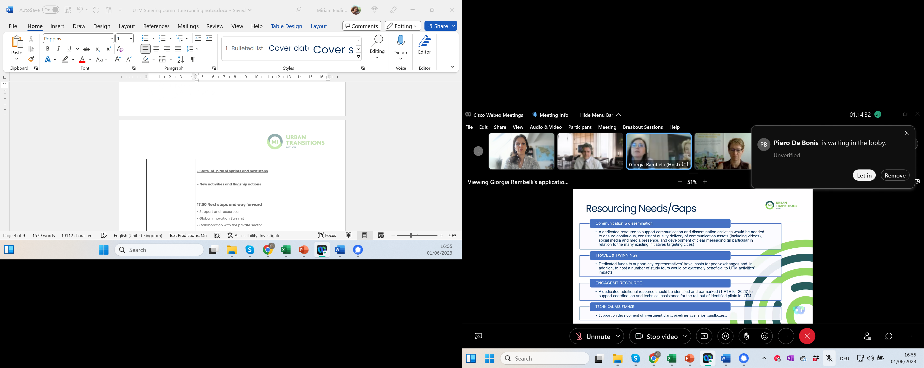  - Dedicate resource to support comms activities (thanking generous supported provided by GCoM , but acknowledging more support is needed in particular to effectively reach out to new cities to join the cohort).  - Funds to support travelling in events and peer-exchanges to be organised (lack of resources hinders peer exchange opportunities and presence at key events).  - 1 FTE to help support of coordination and TA to current cities and considering the expansion of the cohort to an additional 250 cities - including support to coordination of the engagement of Private sector and support offers provided by additional GIA members, and or the roll out pilots and capacity building.  - Additional resources to provide Technical assistance, particularly on investment plans, scenario, developing regulatory sandboxes, …  OPEN DISCUSSION  Q1: Philippe – Resources needed for the evaluation of the 250 proposals/EoI for the next call. What contingency measures are available?  A1: Giorgia – evaluations will be carried out on a rolling basis but realistically there will be a rush close to the deadline - it is worrisome – even more of concern right ne is the capacity to reach out to reach the 250 cities mark, hence need for support on communication and assistance.  We have a spreadsheet, evaluation form and scoring but the analysis needs time. Challenges of the evaluation are important, but also the challenge to get the cities to apply - mobilisation of networks and contacts by the GIA is also key.  Q2: GRAEME - very interested in heat recovery from industry. We have identified 310 TWh of recoverable heat in the UK - >70% of out total heat demand. Perhaps we should discuss a potential collaboration outside of this?  A2: Giorgia – happy to further explore - this could become a sprint  Q3: CRISTINA GOMEZ – how to bring the platform and network of experts that WEF has at the service of the UTM cities? Twinning cities is at the core of their work. Shall we organise an offline conversation with UTM team or a brainstorming with GIA/SteerCo?  WEF already organised sth in cities on extreme heat, how can that be connected with IC7 and Graeme’s suggestions?  A3: Giorgia – There are activities in the GIA that are complementary. We can bring together components from the existing efforts by different partners and engage the cities that highlighted extreme heat/cooling in their priorities.  Combining needs and resources. Avoid overlapping, increase synergies and engaging more cities is essential for the UTM to deliver on its goals.  UTMC can support the identification of what can be shared and connected. Entry points to other platforms can be made available in the UTMC  SteerCo partners are reminded to send the commitment letters to UTM team.  Q4: EMINA – What is the budget for this call?  A4: Giorgia – So far the support that has been provided to the UTM cities is coming mostly from the co-leads GCoM and European Commission. GIA members - UNFCCC, IRENA, IEA, ICLEI have provided in-kind support through training but there is no other budget allocated to these activities. For UTM to continue deliver technical assistance, piloting support and effective capacity building, resources and support by the core and support group partners need to be ensured (FTE., in-kind,…).  Steer co and other GIA members are invited to share their interest and priorities in providing resources and support in line with needs expressed by the cohort.  Q5: IGNACIO – new election coming, likely stand-still in possible support until September. Similar situation at the local level – lowering capacity for new cities to engage.  Q6: ANDY – GCoM Budget for mayoral travel has been available, focusing on higher profile board mayors as possible, but additional support by Steer Co. and core group partners is invited.  Q7: HANS-GÜNTHER – where do the funding for investment come from, beyond the MI Calls? Cities in Austria may be interested to join but wish for funding.  A7: Giorgia – Dialogue with private sector and venture capital (UNFCCC) to mobilise resources is ongoing. TA offered to cities to help them to get ready to be in dialogue with private investors.  Overall offer for UTM Cities includes also joining MICalls, but we will need to open up closer dialogue with funding institutions (such as EBRD and EIB).  We cannot offer direct funding but opportunities to connect to existing funding opportunities, such as Global Infrastructure Basel.  A7: ANDY – blended finance vehicles under preparation by C40, GCoM,… to be launched at COP for example  Giorgia/Miriam will prepare a table (part of the action plan) highlighting what each city did and piloted in the framework of the UTM.  Q8: EMINA – what is the relation between EU Mission and UTM?  A8: Giorgia/Miriam are preparing a paper to clarify the EC Mission/UTM relationship. A summary is already included in the FAQ for the city call, where EC Mission-UTM relationship can be found https://urbantransitionsmission.org/wp-content/uploads/2023/05/Frequently-Asked-Question-FAQ.pdf  Beyond the soon to be launched UTMC, good practices that could be shared include e.g. experiences for cities in Spain – business plan rethinking the way they think and could be leveraged.  New activities and flagship actions  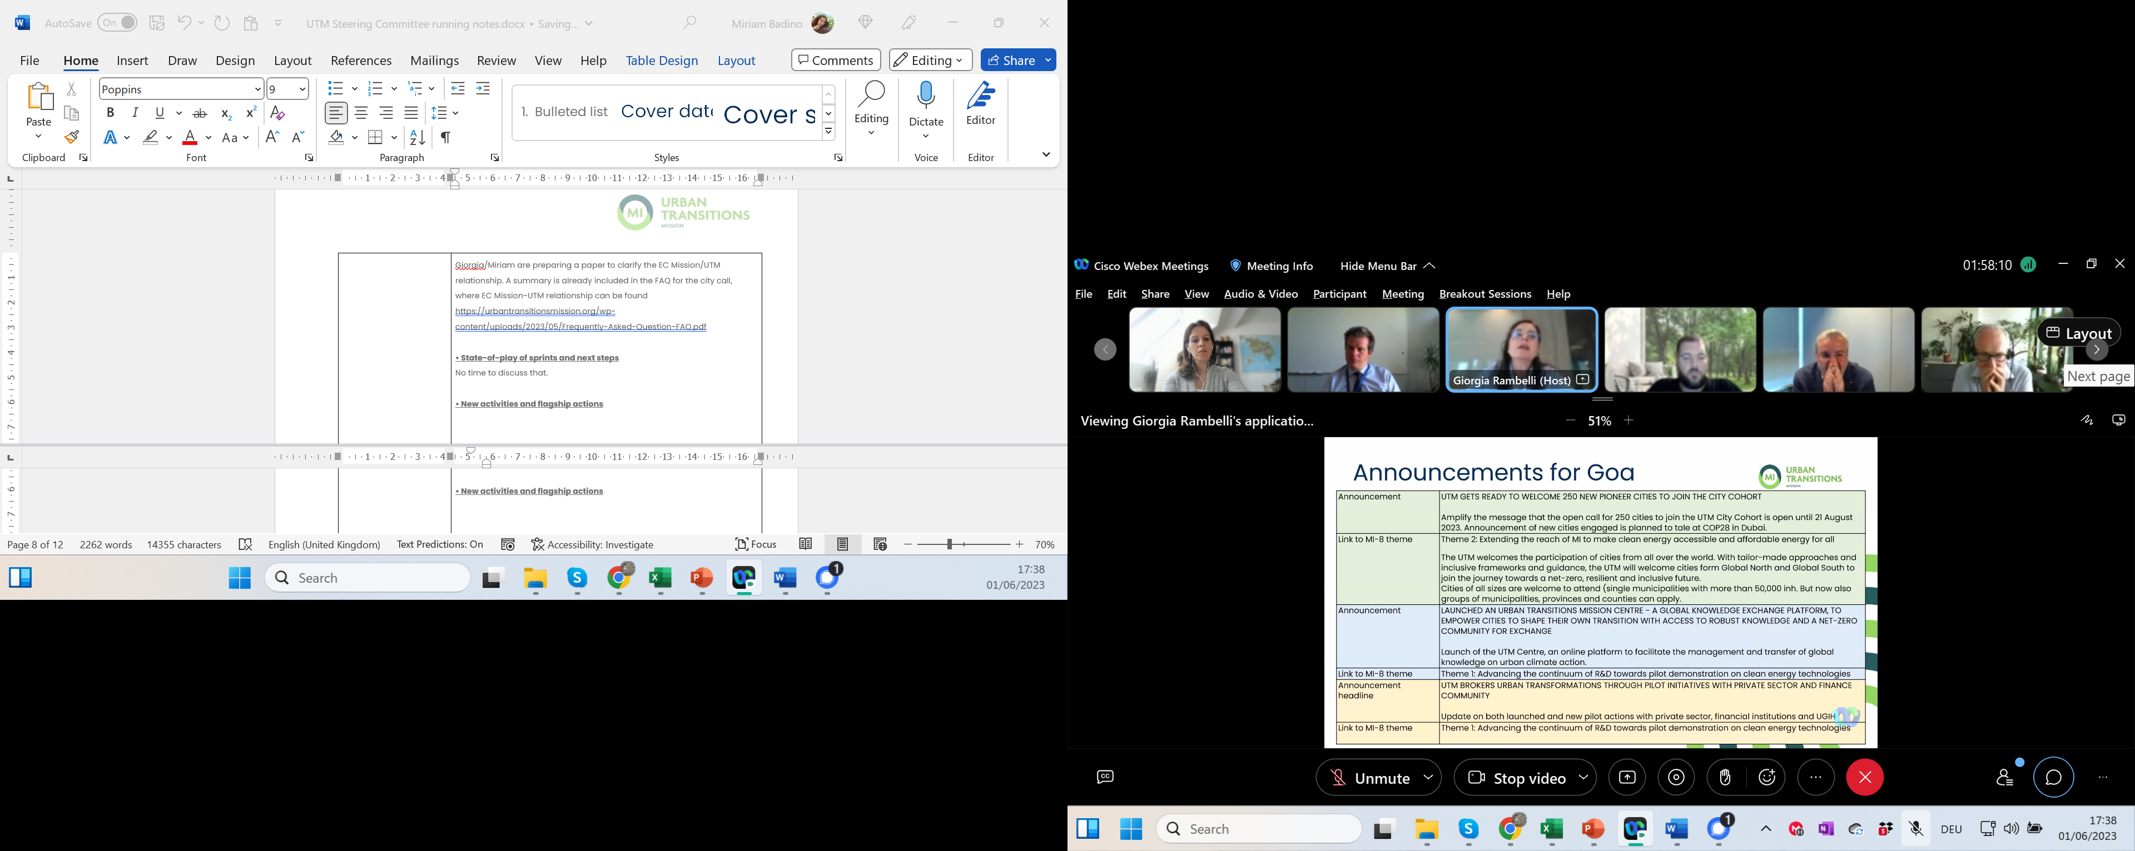  Collaboration with the private sector  So far, following the developed principles and frameworks for cooperation with the private sector, existing cooperation and agreements with specific private companies have been leveraged.  E.g. of cooperation being developed is the selection of 7 pilot cities have for a collaboration with KPMG. This would include the development of an open platform for city to business discussion, and the provision of a light touch digital twin, to be used as a basis for market assessment.  MI Sec will organise a specific workshop, opened to discuss private sector engagement (proposed for mid-June).  - Giorgia suggests to open to the whole GIA.  - Among the themes of the workshop: procurement policies and competition issue raised by cities; dealing with different sizes (from multi-national to start-up) companies and private sector.  Hans-Günther will retire early October, so he will not participate to the next meetings.  The Steering Committee wishes him all the best for this new chapter.
AGREEMENTS and action items | - Giorgia/Miriam to share minutes and slide deck  - All – disseminate call #2 through their own networks  - All – consider needs flagged and identify resources and priority areas to support the UTM activities  - Giorgia/Miriam to share the revise the action plan, to support ALL in identifying areas where contributions are possible and of interest.  - Giorgia to share a date for the MI Sec workshop on private sector  - Giorgia/Miriam will prepare a table (part of the action plan) highlighting examples of cities’ pilot actions in the framework of the UTM.  - Miriam to share invite to the UTMC launch

